# **PF LAB 05 TASKS**

**SECTION 1: Nested if-else Statements**

**Example 1:**

**SOURCE CODE**

#include <stdio.h>

int main()

{

int score;

printf("Enter your score: ");

scanf("%d", &score);

if (score >= 90) {

if (score >= 95) {

printf("Grade: A+\n");

}

else {

printf("Grade: A\n");

}}

else if (score >= 80) {

if (score >= 85)

{

printf("Grade: B+\n");

}

else {

printf("Grade: B\n");

}}

else {

printf("Grade: C or lower\n");

}

return 0;

}

**OUTPUT**

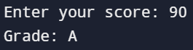

**Example 2:**

**SOURCE CODE**

#include <stdio.h>

int main()

{

int temperature;

printf("Enter the temperature in Celsius: ");

scanf("%d", &temperature);

if (temperature >= 30)

{

if(temperature >= 40)

{

printf("It's very hot outside!\n");

}

else {

printf("It's hot outside.\n"); }

}

else if (temperature >= 20) {

printf("It's warm outside.\n");

}

else if (temperature >= 10) {

printf("It's cool outside.\n");

}

else {

printf("It's cold outside.\n");

}

return 0;

}

**OUTPUT**

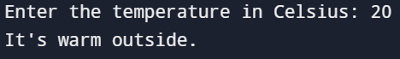

**Problem 1:** Write a program that categorizes a person's age into different life stages: Child, Teenager, Adult, and Senior, using nested if-else statements.

**SOURCE CODE**

#include <stdio.h>

int main()

{

int age;

printf("Enter your age: ");

scanf("%d", &age);

if (age >= 0) {

if (age <= 12) {

printf("You are a Child.\n");

} else if (age <= 19) {

printf("You are a Teenager.\n");

} else if (age <= 59) {

printf("You are an Adult.\n");

} else {

printf("You are a Senior.\n");

}

}

else {

printf("Invalid age.\n");

}

return 0;

}

**OUTPUT**



**Problem 2:** Create a program that determines if a number is positive, negative, or zero, and if it’s positive, checks if it’s an even or odd number.

**SOURCE CODE**

#include <stdio.h>

int main()

{

int num;

printf("Enter an integer: ");

scanf("%d", &num);

if (num > 0) {

printf("The number is positive.\n");

if (num % 2 == 0) {

printf("The number is even.\n");

} else {

printf("The number is odd.\n");

}

} else if (num < 0) {

printf("The number is negative.\n");

} else {

printf("The number is zero.\n");

}

return 0;

}

**OUTPUT**

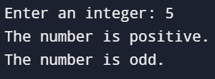

**SECTION 2: Logical Operators**

**Example 1:**

**SOURCE CODE**

#include <stdio.h>

int main()

{

int age = 20;

int hasLicense = 1;

if (age >= 18 && hasLicense)

{

printf("You are eligible to drive.\n");

}

else

{

printf("You are not eligible to drive.\n");

}

return 0;

}

**OUTPUT**



**Example 2:**

**SOURCE CODE**

#include <stdio.h>

int main()

{

int score1, score2, score3;

printf("Enter three test scores: ");

scanf("%d %d %d", &score1, &score2, &score3);

if (score1 > 50 && score2 > 50 && score3 > 50)

{

printf("You passed all the tests.\n");

}

else

{

printf("You did not pass all the tests.\n");

}

return 0;

}

**OUTPUT**

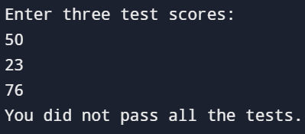

**Problem 1:** Write a program that checks if a number is divisible by both 3 and 5 using logical operators.

**SOURCE CODE**

#include <stdio.h>

int main()

{

int num;

printf("Enter a number: ");

scanf("%d", &num);

if ((num % 3 == 0) && (num % 5 == 0))

{

printf("%d is divisible by both 3 and 5.\n", num);

}

else

{

printf("%d is not divisible by both 3 and 5.\n", num);

}

return 0;

}

**OUTPUT**

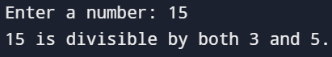

**Problem 2:** Create a program that checks if a person is eligible to vote based on their age and citizenship status.

**SOURCE CODE**

#include <stdio.h>

int main()

{

int age;

char citizenship;

printf("Enter your age: ");

scanf("%d", &age);

printf("Are you a citizen? (Y/N): ");

scanf(" %c", &citizenship);

if (age >= 18 && citizenship == 'Y') {

printf("You are eligible to vote.\n");

} else {

printf("You are not eligible to vote.\n");

}

return 0;

}

**OUTPUT**

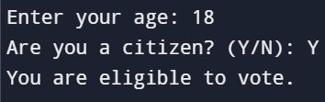

**SECTION 3: Conditional (Ternary) Operators**

**Example 1:**

**SOURCE CODE**

#include <stdio.h>

int main()

{

int number;

printf("Enter a number: ");

scanf("%d", &number);

(number % 2 == 0) ? printf("Even\n") : printf("Odd\n");

return 0;

}

**OUTPUT**

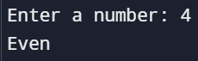

**Example 2:**

**SOURCE CODE**

#include <stdio.h>

int main()

{

int age;

printf("Enter your age: ");

scanf("%d", &age);

age >= 18 ? printf("You are eligible to vote.\n") : printf("You are not eligible to vote.\n");

return 0;

}

**OUTPUT**

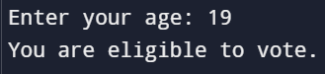

**Problem 1:** Write a program using a ternary operator to find the maximum of two numbers.

**SOURCE CODE**

#include <stdio.h>

int main()

{

int num1, num2, max;

printf("Enter two numbers: ");

scanf("%d %d", &num1, &num2);

max = (num1 > num2) ? num1 : num2;

printf("The maximum of %d and %d is: %d\n", num1, num2, max);

return 0;

}

**OUTPUT**

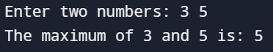

**Problem 2:** Use the ternary operator to check if a number is positive, negative, or zero.

**SOURCE CODE**

#include <stdio.h>

int main()

{

int num;

printf("Enter a number: ");

scanf("%d", &num);

const char* result = (num > 0) ? "Positive" : ((num < 0) ? "Negative" : "Zero");

printf("The number is %s.\n", result);

return 0;

}

**OUTPUT**

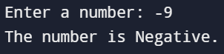

**SECTION 4: Bitwise Operators**

**Example 1:**

**SOURCE CODE**

#include <stdio.h>

int main()

{

int a = 5;

int b = 9;

printf("a & b = %d\n", a & b);

printf("a | b = %d\n", a | b);

printf("a ^ b = %d\n", a ^ b);

printf("~a = %d\n", ~a);

return 0;

}

**OUTPUT**

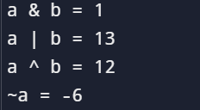

**Example 2:**

**SOURCE CODE**

#include <stdio.h>

int main()

{

int a = 5;

int result = a << 1;

printf("Result after left shift: %d\n", result);

return 0;

}

**OUTPUT**



**Problem 1:** Write a program to swap two numbers using bitwise XOR.

**SOURCE CODE**

#include <stdio.h>

int main()

{

int a, b;

printf("Enter two numbers:\n");

scanf("%d %d", &a, &b);

a = a ^ b; // Step 1: a becomes a XOR b

b = a ^ b; // Step 2: b becomes (a XOR b) XOR b = a

a = a ^ b; // Step 3: a becomes (a XOR b) XOR a = b

printf("After swapping: a = %d, b = %d\n", a, b);

return 0;

}

**OUTPUT**

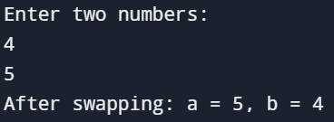

**Problem 2:** Create a program that counts the number of 1s in the binary representation of a number.

**SOURCE CODE**

#include <stdio.h>

int main()

{

int number, count = 0;

printf("Enter a number: ");

scanf("%d", &number);

while (number > 0)

{

count += number & 1;

number >>= 1;

}

printf("The number of 1s in the binary representation is: %d\n", count);

return 0;

}

**OUTPUT**

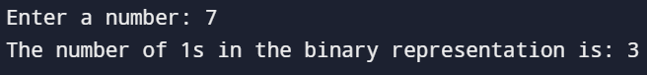

**SECTION 5: Modulus Operator**

**Example 1:**

**SOURCE CODE**

#include <stdio.h>

int main()

{

int number;

printf("Enter a number: ");

scanf("%d", &number);

if (number % 2 == 0)

{

printf("The number is even.\n");

}

else

{

printf("The number is odd.\n");

}

return 0;

}

**OUTPUT**

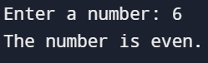

**Example 2:**

**SOURCE CODE**

#include <stdio.h>

int main()

{

int num;

printf("Enter a number: ");

scanf("%d", &num);

if (num % 5 == 0)

{

printf("The number is divisible by 5.\n");

}

else

{

printf("The number is not divisible by 5.\n");

}

return 0;

}

**OUTPUT**

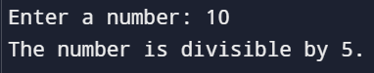

**Problem 1:** Write a program that checks if a year is a leap year using the modulus operator.

**SOURCE CODE**

#include <stdio.h>

int main()

{

int year;

printf("Enter a year: ");

scanf("%d", &year);

if ((year % 4 == 0 && year % 100 != 0) || (year % 400 == 0))

{

printf("%d is a leap year.\n", year);

}

else

{

printf("%d is not a leap year.\n", year);

}

return 0;

}

**OUTPUT**

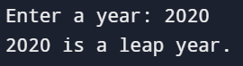

**Problem 2:** Create a program that calculates the sum of digits of a number until the result is a single digit (e.g., 123 -> 6).

**SOURCE CODE**

#include <stdio.h>

int main()

{

int number, sum, digit;

printf("Enter a number: ");

scanf("%d", &number);

while (number >= 10)

{

sum = 0;

while (number != 0)

{

digit = number % 10;

sum += digit;

number /= 10;

}

number = sum;

}

printf("The single-digit sum is: %d\n", number);

return 0;

}

**OUTPUT**

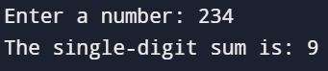

**PROBLEMS**

1. Write a program to find the greatest of three numbers using nested if-else statements.

**SOURCE CODE**

#include <stdio.h>

int main()

{

int num1, num2, num3;

printf("Enter three numbers: \n");

scanf("%d %d %d", &num1, &num2, &num3);

if (num1 >= num2) {

if (num1 >= num3)

{

printf("The greatest number is: %d\n", num1);

} else {

printf("The greatest number is: %d\n", num3);

}

} else {

if (num2 >= num3) {

printf("The greatest number is: %d\n", num2);

} else {

printf("The greatest number is: %d\n", num3);

}

}

return 0;

}

**OUTPUT**

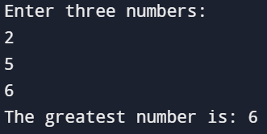

1. Create a program that calculates the final grade of a student based on multiple criteria, including attendance, assignment scores, and exam results, using nested decision structures.

**SOURCE CODE**

#include <stdio.h>

int main()

{

float attendance, assignment, exam, finalGrade;

printf("Enter attendance percentage (out of 100): ");

scanf("%f", &attendance);

printf("Enter assignment score (out of 100): ");

scanf("%f", &assignment);

printf("Enter exam score (out of 100): ");

scanf("%f", &exam);

if (attendance >= 75) {

if (assignment >= 50) {

if (exam >= 50) {

finalGrade = (attendance * 0.2) + (assignment * 0.3) + (exam * 0.5);

printf("Final Grade: %.2f\n", finalGrade);

if (finalGrade >= 90) {

printf("Letter Grade: A\n");

} else if (finalGrade >= 80) {

printf("Letter Grade: B\n");

} else if (finalGrade >= 70) {

printf("Letter Grade: C\n");

} else if (finalGrade >= 60) {

printf("Letter Grade: D\n");

} else {

printf("Letter Grade: F\n");

}

} else {

printf("Failed due to insufficient exam score (below 50).\n");

}

} else {

printf("Failed due to insufficient assignment score (below 50).\n");

}

} else {

printf("Failed due to low attendance (below 75%%).\n");

}

return 0;

}

**OUTPUT**

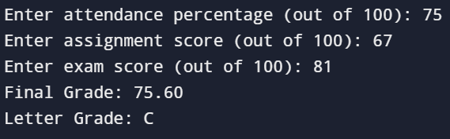

1. Write a program that uses bitwise operators to perform encryption and decryption of a character.

**SOURCE CODE**

#include <stdio.h>

int main()

{

char ch, encryptedChar, decryptedChar;

int key = 6;

printf("Enter a character to encrypt: ");

scanf("%c", &ch);

encryptedChar = ch ^ key;

printf("Encrypted character: %c\n", encryptedChar);

decryptedChar = encryptedChar ^ key;

printf("Decrypted character: %c\n", decryptedChar);

return 0;

}

**OUTPUT**

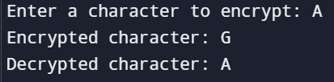

1. Develop a program that uses logical operators to determine if a person is eligible for a loan based on age, income, and credit score.

**SOURCE CODE**

#include <stdio.h>

int main()

{

int age;

double income;

int creditScore;

printf("Enter your age: ");

scanf("%d", &age);

printf("Enter your annual income (in dollars): ");

scanf("%lf", &income);

printf("Enter your credit score: ");

scanf("%d", &creditScore);

if ((age >= 18 && age <= 65) && income > 25000 && creditScore >= 650) {

printf("You are eligible for the loan.\n");

} else {

printf("You are not eligible for the loan.\n");

}

return 0;

}

**OUTPUT**

